WestCam(Pty) Ltd

Crabtree Endurance Panel System

Technical Manual

V1.0

by
Michael Westwood
mikewestwood@gmail.com
083 678 2601

Table of Contents
Hardware 2
Devices 2
Functions 3
Software 4
Platform 4
Drivers and Libraries 4
Labview Application 4
User Interface 4
Synopsis 4
Fault Handling 4
Code Documentation 5
Web Interface 5
Passwords 6

Hardware

Devices
Advantech USB-4704 Data Acquisition module
- Analog Inputs - 8 single ended configuration used. 11bit resolution
- Analog Outputs - 3 Channels, Resolution 12 bits
- Digital Outputs - 4 Channels, TTL
USB 4704
MXTHV10
This is a custom made thermocouple amplifier card which communicates via RS485 serial.
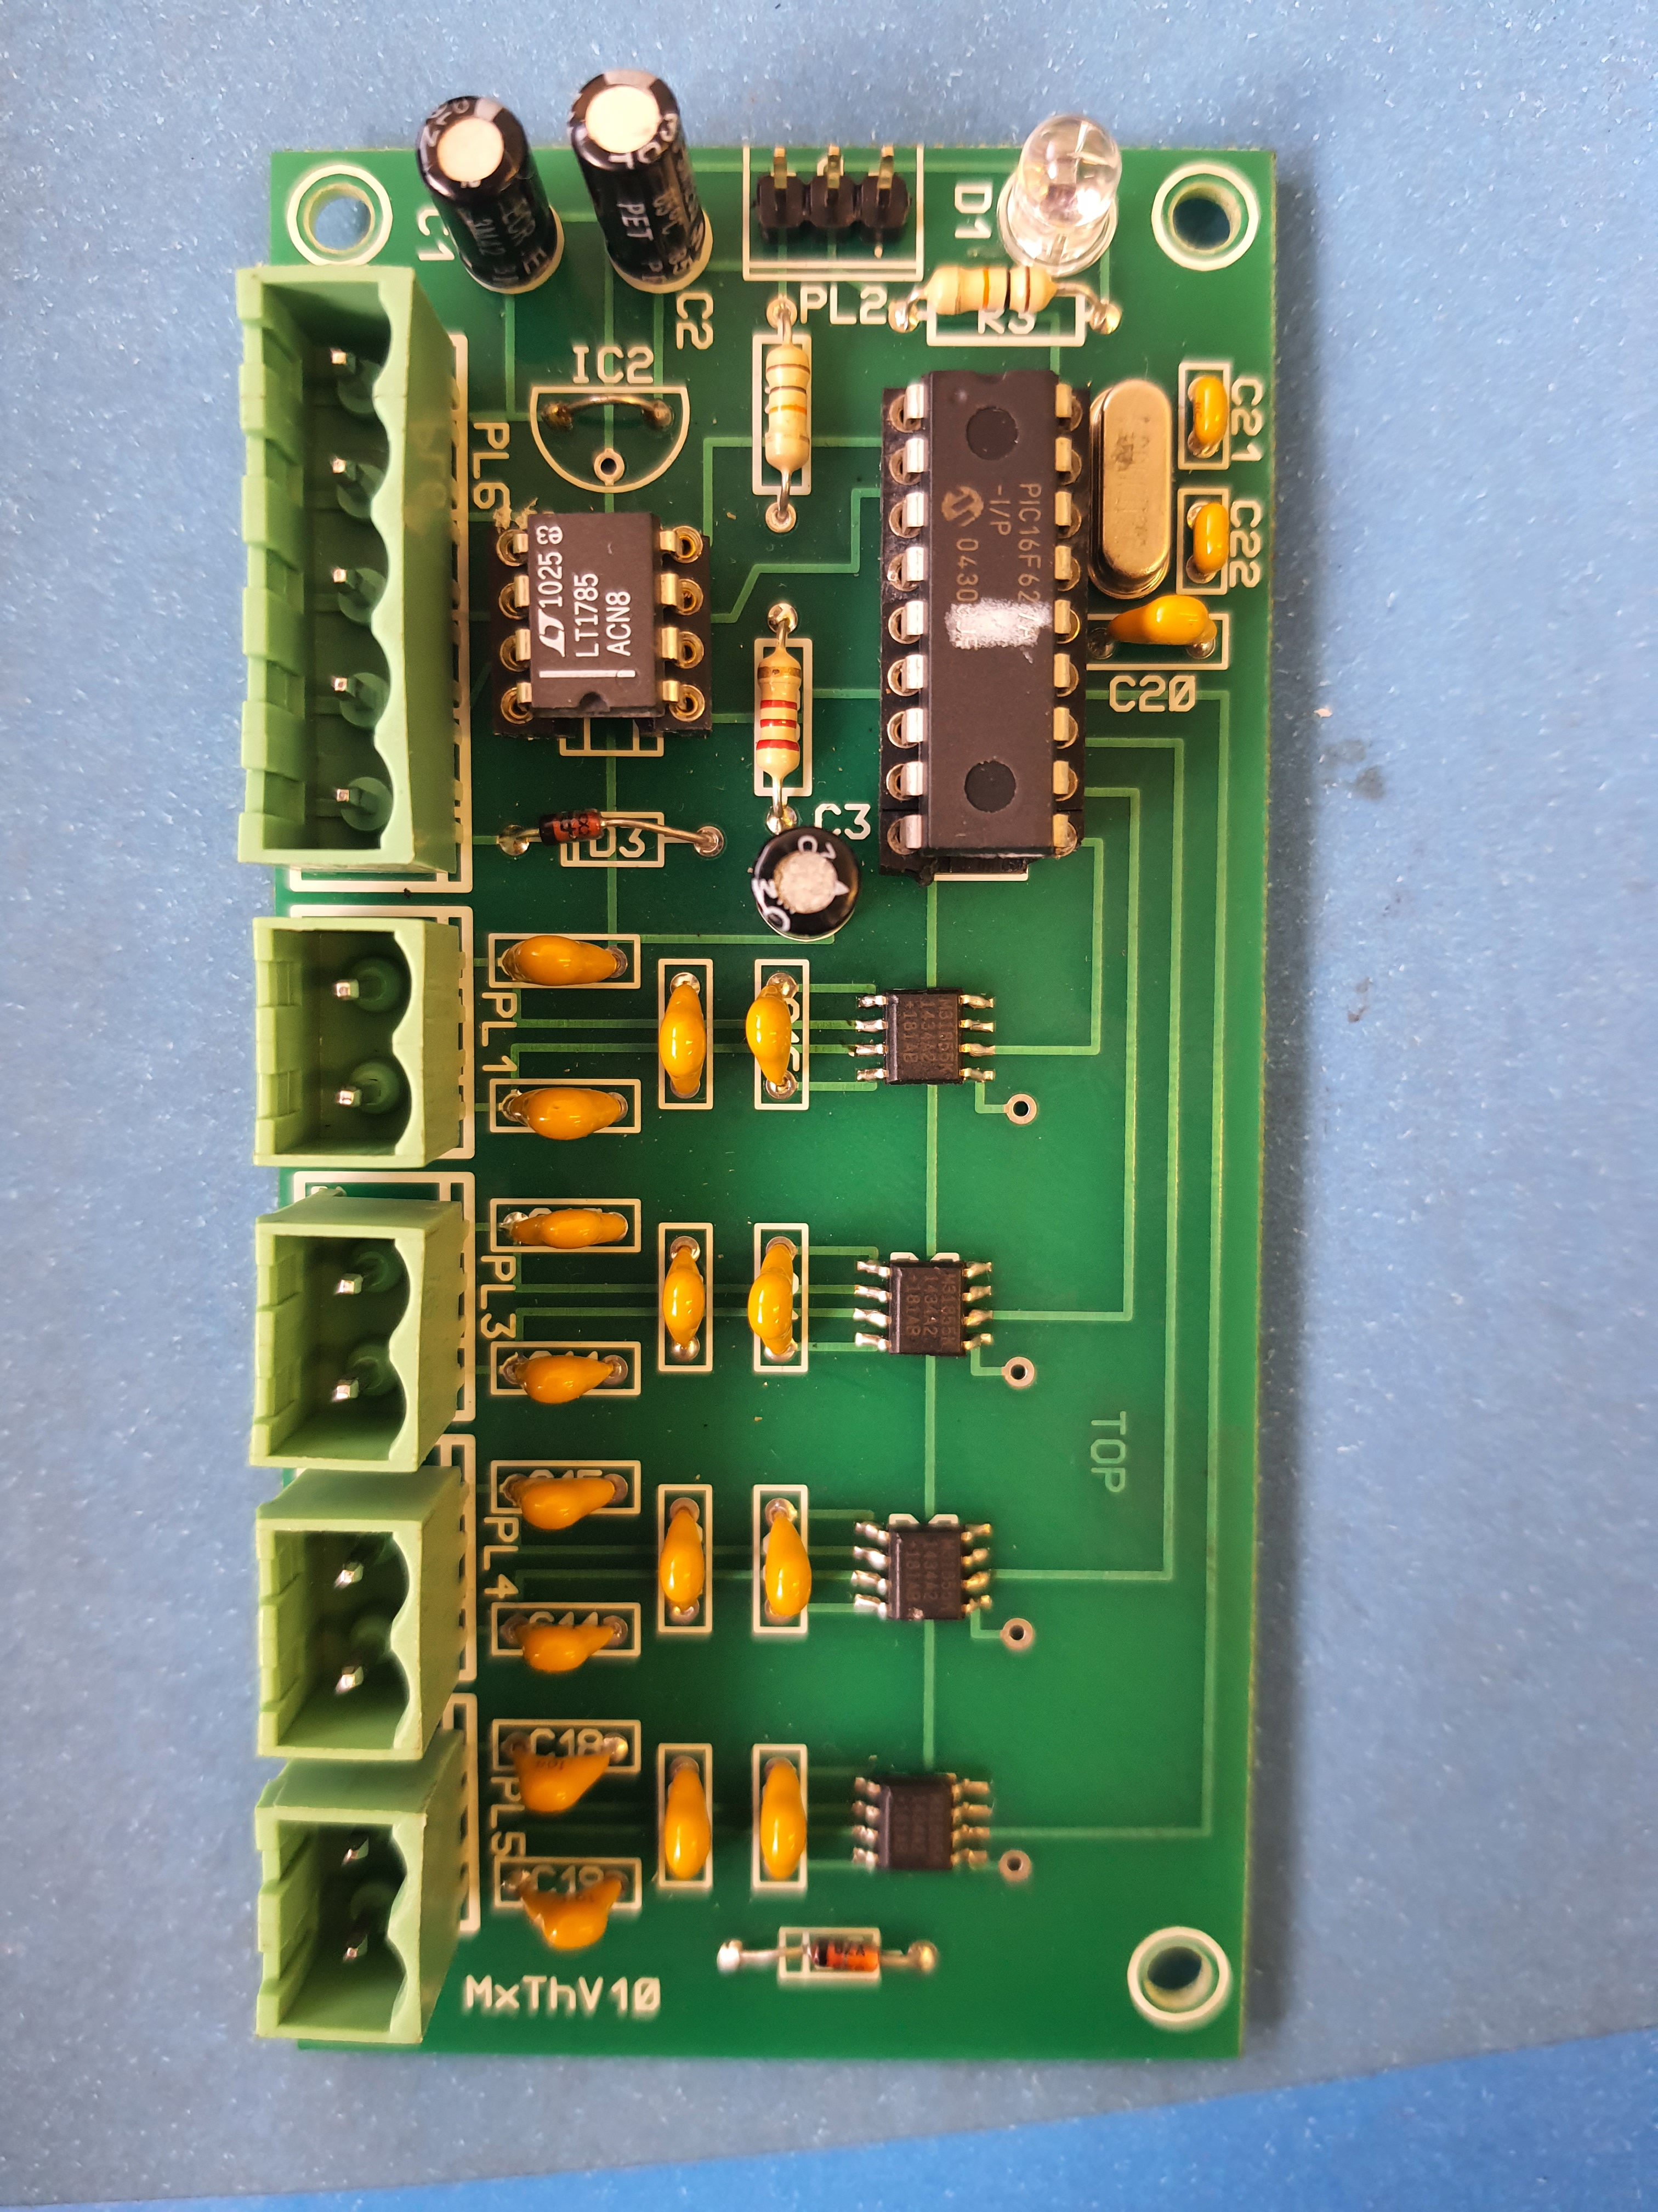MXTHV10

ICP DAS I-7520
RS232 - RS485 bridge. This is is used to communicate with the MXTHV10 cards.
ICP DAS I-7520

Functions
- Voltages and Currents are measured by the Advantech DAQ units' Analog inputs (USB).
- Ambient temperature is measured by Advantech DAQ unit No. 3 analog input
- Temperature is measured by the MXTHV10 thermocouple transmitter cards.
- Jigs are controlled via the digital outputs of the Advantech 4704.

Software

Platform
- The software is written using National Instruments LabVIEW 2013 running on Microsoft Windows.

Drivers and Libraries
- Advantech DAQNavi driver for USB-4704
- Advantech DAQNavi LabVIEW Library
- National Instruments Electrical Power Toolkit

Labview Application

User Interface
This is covered in the CRAB100-1 RV01-2 document.

Synopsis
The Labview application automatically performs the following functions for LAB01 to LAB05.
- Configuration of tests for each Lab Panel including Name, Description, Number of Cycles, Temperature rise time (minute) and Temperature rise limit (degree)
- Jig Control, i.e., Start/Stop/Reset Test.
- Acquisition of Live and Neutral currents and voltages.
- Calculation of power factors and power.
- Acquisition of terminal temperatures.
- Calculation of Pass/Fail for
- Temperature Rise
- High Current
- Low Current
- Graphing and display of graph data.
- Display of live data and logs
- Logging of data to file to a National Instruments TDMS file.
- Email of report when a test is complete.
- Web server for remote access.

Fault Handling
- In the event of an analog read fault, the USB Reset routine is executed during which the DAQNavi task is destroyed and re-created. This can also be done manually using the Reset Measuring button on the front panel.
- The application is terminated if a Reset Error occurs

Code Documentation
This takes the form of comments in the LabVIEW code

Email
The Endurance Panel PC must be added to the Allow List of the mail server.
Settings:
Mail Server : 10.86.192.231
From Address : smtp-relay@crabtree.co.za
Username : not used
Password : not used
To : Comma separated list of recipients email addresses

To test the email function outside LabVIEW, follow the procedure described here:
https://learn.microsoft.com/en-us/exchange/mail-flow/test-smtp-telnet?view=exchserver-2019

Web Interface
This uses the Silverlight plugin which is no longer supported. The web page can be viewed in Microsoft Edge, but it is necessary to enable Internet Explorer mode in the PC group policy. To
do this follow the procedure below
- Type Edit Group Policy into the windows search box and click on Open
- Select User Configuration - Administrative Templates – Windows Components-Microsoft Edge (see the screenshot below)
- Click on “Send all Intranet Site to Internet Explorer” and select Enabled

\

Passwords
- Simulation : 9949
- Admin: 9949
____________________

